|  |  |  |  |
| --- | --- | --- | --- |
|  | **Assignment No. 1 Semester: Fall 2025**  **CS201 – Introduction to Programming** | | **Total Marks: 20**  **Due Date: 07/11/2025** |
| **Instructions**  **Please read the following instructions carefully before submitting assignment:**  **It should be clear that your assignment will not get any credit if:**   * **Assignment is submitted after due date.** * **Submitted assignments do not open or file is corrupt.** * **Assignment is copied (From internet/students).** * **Assignment is submitted in any file format other than .cpp.**   **Recommended tool to develop Assignment**   * **Dev C++**   **Objectives:**  To enable students to understand and practice the concepts of:   * Loops * Function * Switch * if-else   **Assignment Submission Instructions**   1. **You must submit only .cpp file on the assignments interface of CS201 from your LMS account.** 2. **Assignment submitted in any other format will be scaled with zero marks. So, check your solution file format before submission.** 3. **Do not zip the assignment file**   **General Instructions**   1. For any query related to assignment, please contact [cs201@vu.edu.pk](mailto:cs201@vu.edu.pk). 2. Don’t ask queries related to assignment via MDB section as this forum is only for lecture related discussion. 3. There is no need to post done/present/feedback queries on MDB section. 4. If you are facing issues other than lectures, then use vu ticketing system. | | | |
| **Assignment** | |  | |

**Number Classification from Student ID**

**Problem Statement**

Write a C++ program that analyses the numeric part of your hardcoded student ID. For each digit in the ID, your program must first determine if it is a prime number. If it is not prime, classify it as zero, even, or odd. The program should display the classification for each digit and finally report the total count of zeros, even numbers, odd numbers, and prime numbers found.

**Functional Requirements:**

1. The program should include your own Student ID and Name as hard-coded inputs (Do not take ID/Name from user input).
2. Store the numeric part from the ID in a variable.
3. Analyse each digit and check whether it's prime, even, odd, or zero. (one number will have only one tag)
4. Show the total count of prime, even, odd, and zero digits in the ID.

**Required Output Format:**

* Display the student's ID and name
* Print one line per digit with its classification
* End with a summary count of each category

**Output Format**

First line of your output must contain your own VU Student ID and name.

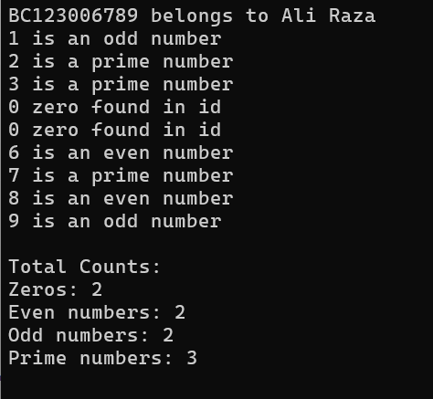

**Syllabus:**

The syllabus for this assignment includes all topics covered from Lecture 1 to Lecture 9.

**Note: Remember that printf and scanf are not allowed. If you use it in the program, your marks will be deducted.**